Joshua Merren

Professor Siddiqi

CYB 210

21 March 2024

Module 3-3 Activity: Subnetting Practice

1. A screen shot of a checklist

   Description automatically generated
2. 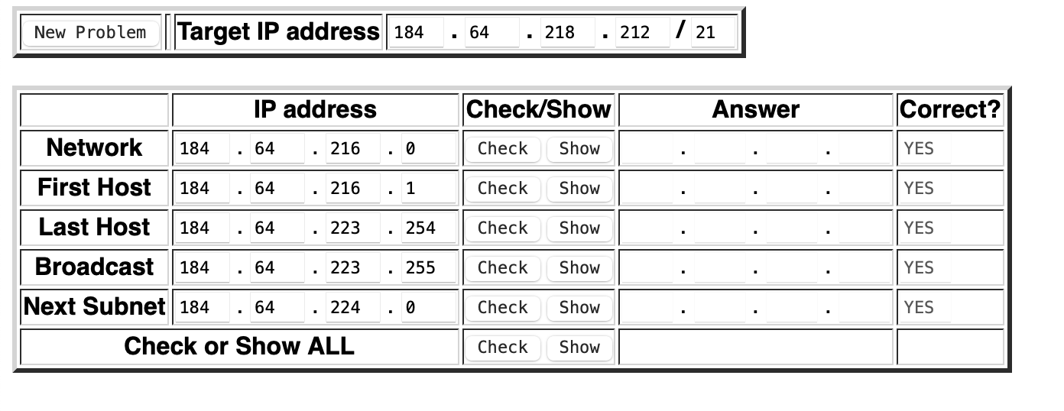
3. A screenshot of a checklist

   Description automatically generated
4. A screenshot of a checklist

   Description automatically generated
5. A screenshot of a checklist

   Description automatically generated